The American Dream 🗽 &  
 European Dream 💶

Table of contents

American Dream 1

Changes 1

Situation Today 1

European Dream 2

Changes 2

Situation Today 3

Summary 3

# American Dream

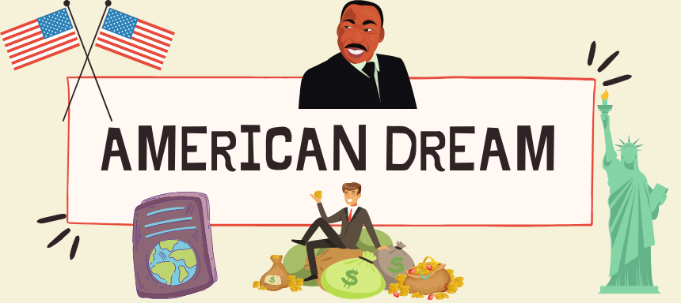The American Dream originally embodied the ideal that every individual, **regardless of background**, could achieve prosperity and success through hard work, determination, and initiative. It emphasized the possibility of upward social mobility and the pursuit of personal happiness and freedom within a democratic society.

## Changes

* Traditional American Dream:
  + Family Values: Family played a central role in the traditional American Dream, with an emphasis on strong familial bonds, marriage, and the ability to provide a better future for one's children.
  + Material Success: Material wealth and consumerism were often seen as markers of success in the traditional American Dream. Achieving a comfortable lifestyle with access to consumer goods and amenities was a common aspiration.
* American Dream (Today):
  + Diversity and Inclusion: The contemporary American Dream recognizes the importance of diversity, equity, and inclusion. It emphasizes equal opportunities for all individuals, regardless of race, gender, sexual orientation, or socioeconomic background.
  + Access to Education and Healthcare: Access to quality education and healthcare is increasingly seen as essential for achieving the American Dream. Rising costs and disparities in these areas have prompted calls for reforms to ensure equal opportunities for all.

## Situation Today

The American Dream today does not include the 2.5 kids, dog, picket fence, and house in the suburbs anymore. Instead, it focuses on **eliminating worries rather than providing comforts**. Today's American Dream is being able to **graduate from college with minimal debt**, **secure a job** in your field that has benefits, **afford health care costs** (while **saving for retirement and paying off loans**), and still live a comfortable life. The American Dream still exists, but it has taken on a new form.

# The European Dream Podcast Download ~ Podcast von Lizzy Steib & Daniel Wagner ~ podcast 3218296European Dream

The European Dream originally envisioned a peaceful, unified continent where diverse nations and cultures could coexist and collaborate harmoniously, fostering prosperity and stability through economic integration and shared values. It aimed to prevent the recurrence of devastating conflicts like the World Wars by promoting cooperation, democracy, and human rights across Europe.

## Changes

* Economic goals
  + Past:
    - Economic recovery and growth were primary goals, with efforts to rebuild war-torn economies and establish a common market
  + Present:
    - While economic stability remains important, there's a stronger emphasis on sustainable growth, reducing inequality, and balancing economic prosperity with social welfare
* Social Welfare
  + Past:
    - The development of social welfare systems was a significant focus, but these systems varied widely across Europe
  + Present:
    - The European Dream includes a more comprehensive and standardized approach to social welfare, aiming to reduce disparities and ensure high-quality healthcare, education, and social services across member states
* Technological Innovation
  + Past:
    - Technological advancement was important but not as coordinated across Europe
  + Present:
    - There's a concerted effort to lead in digital transformation and innovation while protecting privacy and ethical standards, aiming to compete globally in the tech sector
* Cultural and Educational Exchange
  + Past:
    - educational exchange programs were less developed
  + Present:
    - Programs like **Erasmus+** have become integral to the European Dream, fostering greater mutual understanding and learning across borders

## Situation Today

The European Dream today envisions a united and diverse continent prioritizing social welfare, environmental sustainability, peace, and stability. It emphasizes strong social safety nets, equitable economic growth, and global leadership in human rights and climate action. Technological innovation, cultural exchange, and robust governance are also key components. This dream seeks to balance collective well-being with individual freedoms, promoting a high quality of life for all citizens while addressing global challenges responsibly

# Summary

The American Dream champions individual opportunity, success, and material wealth attained through hard work and determination, while the European Dream prioritizes collective well-being, social equality, and a strong social safety net emphasizing quality of life and community cohesions